**Bilateral tennis elbow**

**Initial Assessment**

|  |  |  |
| --- | --- | --- |
| **Presenting Symptom/Chief Complaint** | | |
| Patient is complaining of acute painful syndrome to the both elbow due to sport injury and repetitive movement at work. | | |
| **Main Signs and Symptoms** | | |
| Pain is severe with limitation of arm and wrist movement, tingling and numbness along the arms and fingertips. | | |
| **Other Signs and Symptoms** | | |
| Otherwise patient is healthy. | | |
| **TCM Diagnosis and Treatment (identified TCM disease, TCM differentiation of syndromes)** | | |
| Acute painful obstruction syndrome in both elbow areas due to damp – cold invasion and over extension of the joints. | | |
| **Treatment Principles and Strategies** | | |
| Remove the dampness. Expel cold. Restore the Qi movement at the main channel. Remove Qi obstruction. | | |
| **Treatment Plan (Modalities; acupuncture, herbal, dietary, manual therapies), frequency and duration** | | |
| Acupuncture with distal points ‘sedation and local points’ tonification with session duration for 1 hour every 2 -3 days will the symptoms resolved. | | |
| **Any other Advice Given to Patients** | | |
| Acupuncture: distal points LI (1) (LR), LI4 (LR), TW5 (bilaterally), TW8 with strong stimulation on both sides. Local points LI11 (bilaterally), preferable tonification for 1 hour – relieve painful obstruction syndrome.  Qu Yang Wei – extra point bilaterally (specific point for tennis elbow). TW1- - tip of olecranon  LI12 (to prevent upward radiation of pain). Needling the connecting points of channels on the opposite side (LU6) bilaterally. LU5 (bilaterally) – relax tendons of the arm. | | |
| **Practitioner:** | **Date:** | **Signature:** |

**Bilateral tennis elbow**

**Daily Charting____________________________________Patient Name:** 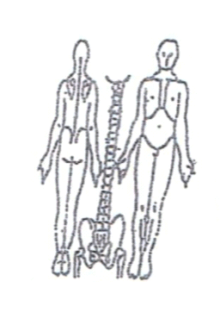

**Working Diagnosis:** Painful obstruction syndrome in both elbow area caused by combination of exposure to damp – cold and over extension of the elbow joints.

S: Patient is complaining of acute sudden episode of pain with extension of elbow during the few days. Pain is radiated to the lateral side of the arms. Numbness and tingling along the arms.

O:

Treatment (P) Acupuncture: distal points LI (1) (LR), LI4 (LR), TW5 (bilaterally), TW8 with strong stimulation on both sides. Local points LI11 (bilaterally), preferable tonification for 1 hour – relieve painful obstruction syndrome. Qu Yang Wei – extra point bilaterally (specific point for tennis elbow). TW1- - tip of olecranon. LI12 (to prevent upward radiation of pain). Needling the connecting points of channels on the opposite side (LU6) bilaterally. LU5 (bilaterally) – relax tendons of the arm.

(A) Acupuncture I hour due to treatment plan.

**Date:_ _______________**

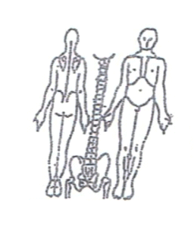**Working Diagnosis:**

S: Patient is still experiences the pain in both arms with movement limitation. Pain is

At the night time and disturbing the sleep. Tired and low energy during the day.

O:

Treatment (P) Acupuncture with Moxibustion 1 hour according to the protocol.

(A)

**Date:_ _______________**

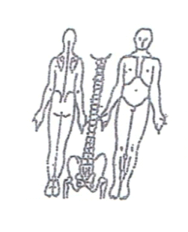**Working Diagnosis:**

S: Patient is still having pain in both arms. Pain in intensity. ROM. N sleep, N level of energy.

O:

Treatment (P) Acupuncture with Moxibustion for 1 hour according to the treatment plan.

(A)

**Date:_**

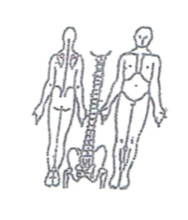**Working Diagnosis:**

S: Pain is . ROM. Can work on the computer with wrist support. N sleep. level of energy.

O:

Treatment (P) Acupuncture with tonification protocol 1 hour as per protocol.

(A)

**Date:_ _______________**

**Working Diagnosis:**

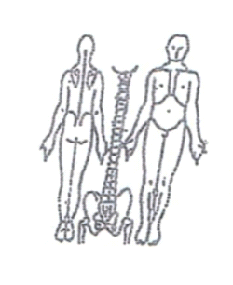S: Patient is feeling well. No pain bilaterally. N ROM. N daily activity and work.

O:

Treatment (P) Starting the stretching exercises. Acupuncture + Moxibustion 1 hour

according to the protocol.

(A)